# Ads – SPA with AngularJS Lab

The **goal of this lab** is to continue the development of the Online Ads AngularJS application: display the public ads.

## Display the Public Ads

1. Write a service to retrieve the public ads from the provided back-end REST service:
   * You should perform a **HTTP GET** request from <http://softuni-ads.azurewebsites.net/api/ads>.
   * The service will return the ads as JSON object.
   * Still no filtering and paging will be performed.
2. Create the Ads service that will load all ads (without filtering and paging):

|  |
| --- |
| **adsServices.js** |
| **'use strict'**;  ***app***.**factory**(**'adsService'**,  **function** ($resource, baseServiceUrl) {  **var** adsResource = $resource(  baseServiceUrl + **'/api/ads'**,  **null**,  {  **'getAll'**: {**method**:**'GET'**}  }  );   **return** {  getAds: **function**(params, success, error) {  **return** adsResource.**getAll**(params, success, error);  }  }  } ); |

5 score

1. Add code to your **HomeController** to load the ads in the **$scope**:

|  |
| --- |
| **HomeController.js** |
| **'use strict'**;  app.*controller*(**'HomeController'**,  **function** ($scope, adsService, notifyService) {  adsService.getAds(  **null**,  **function** *success*(data) {  *//* ***TODO:*** *put the ads in the scope*  },  **function** *error*(err) {  notifyService.showError(**"Cannot load ads"**, err);  }  );  } ); |

10 score

1. Write a code in your home view (**templates/home.html**) to display the ads:

|  |
| --- |
| **home.html** |
| <**ul class="ads"**>  <**li ng-repeat="ad in ads.ads" class="box"**>       <**h1**>{{ad.**title**}}</**h1**>       <**div**><**strong**>Date:</**strong**> {{ad.**date** | **date**:'dd-MMM-yyyy'}}</**div**>       <**div ng-if='ad.imageDataUrl'**>  <**strong**>Image:</**strong**>  <**img class="ad-image" ng-src="{{ad.imageDataUrl}}"** />       </**div**>  *//* ***TODO:*** *display all other fields for the current ad*  </**li**>  </**ul**>  <**div ng-if="ads.ads.length==0" class="box no-data"**>  No ads found.  </**div**> |

15 score

1. Start and test your application. Fix all bugs. Check the development console. It should be error free:

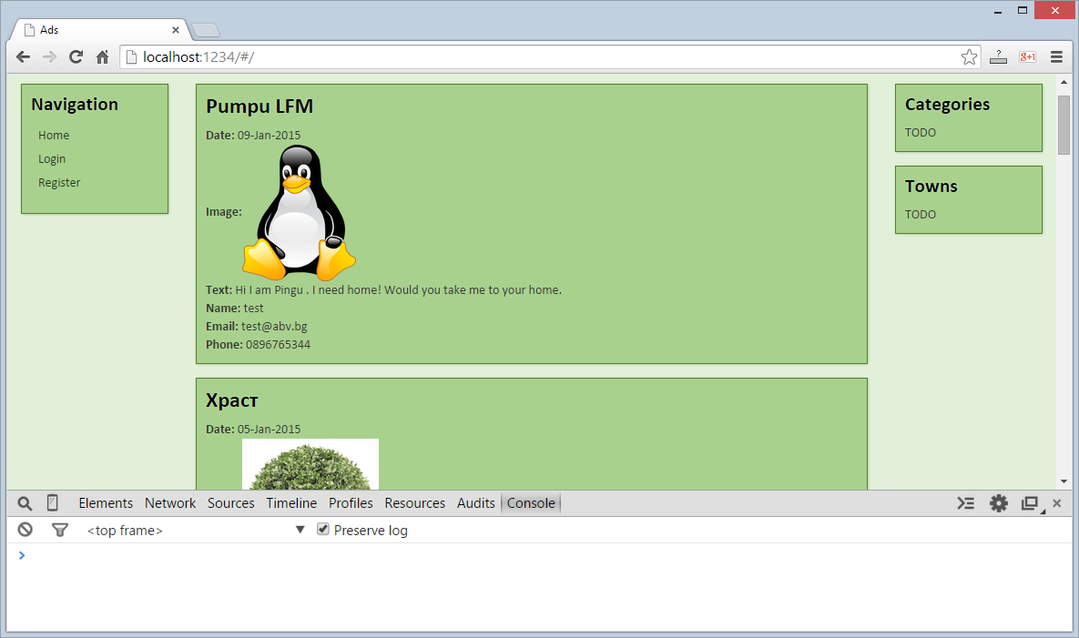10 score